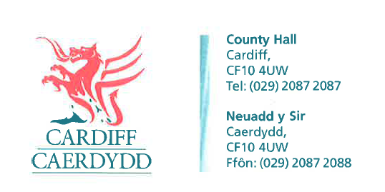
FOI07146
Thank you for your request under the Freedom of Information Act 2000 about National Express Bus station in Sophia Gardens received on 11/08/2015.
We have considered your request and enclose the following information:
- What noise and environmental pollution tests did the Council conduct prior to allowing this bus station to be approved.
None
- Did the Council insist on National Express coaches leaving in a southerly direction - i.e. turn left out of Sophia Gardens rather than turning right and travelling up Cathedral Road
No
- Did the council consult any of the residents on Cathedral road prior to this bus station approval
No
- The area of land that the Coach Station is currently sited on has a covenant placed on it – stating that the land is not for commercial use. I believe National Express paying the council to use this area contravenes this; this also applies to the Car Park, circus and other such events.

There are two conveyances for the land at Sophia Gardens both dated the 24th June 1948 and made between Mountjoy Limited and The Lord Mayor Aldermen and Citizens of the City of Cardiff. The first conveyance relates to land south of Sophia Close across to the river Taff and into Bute Park. This is the one that has the covenant which states: “the Corporation should obtain from the company holding the benefit of the covenant, consent to erect on the land any additional permanent buildings other than pavilions bandstands shelters and other buildings or erections usual in public parks and open spaces”. It also specifies that the land will be used for any local public purpose or for the benefit of the inhabitants of the city. It does not specifically say that it is not for commercial use.

If you have any queries or concerns, please do not hesitate to contact us.
Please remember to quote the reference number above in any future communications.

